**Conway Game of Life**

For the simple game created, 1 represent cell live and 0 is cell dead. The game of line pattern is represent using matrix. The initial patterns are: blinker, toad and beacon which are drawn in matrix pattern.

The rules of the game from Wikipedia are:

1. Any live cell with fewer than two live neighbours dies, as if caused by underpopulation.
2. Any live cell with two or three live neighbours lives on to the next generation.
3. Any live cell with more than three live neighbours dies, as if by overpopulation.
4. Any dead cell with exactly three live neighbours becomes a live cell, as if by reproduction.

The live (1) or died (0) cell will check on their neighbour cell’s status (die or live) and decide whether the cell is 1 or 0. For a normal cell, it will check on 8 neighbours while cell situated near the edges will check on the available neighbours only.

**Coding output:**

1. blink

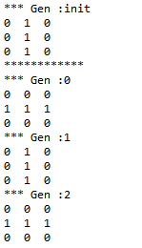

2. toad

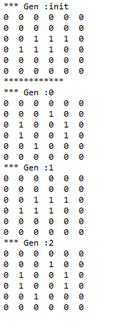

3. beacon

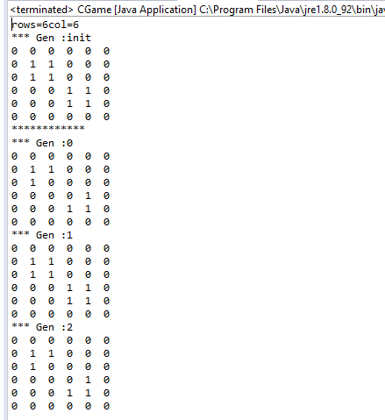

**Challenges of the program:**

The challenge is to come up with the coding to make each cell to check their neighbours as each cell are situated at different location and different checking mechanism will be needed based on the cell’s matrix.